Author: Harriet McGuire

**Chissano, Alberto (1935-1994)**

Alberto Mabungulane Chissano first tried his hand at wood sculpture in 1964, and in the first decade of his career had his work displayed in multiple local and international group exhibitions. By 1972 Chissano held his first solo exhibition abroad. Before Mozambique’s independence from Portugal in 1975, the Chissano Museum Gallery in Matola, a suburb of the capital, Maputo (formerly Lourenco Marques), was established in his home and he had the first of several generations of Mozambican sculptors learning the secrets of working in mafora and sandalwood at his side. Among the well-known Mozambican sculptors who trained at Chissano’s studio are Naftal Langa (1932-2014), Muando (1960 --), and Ndlozy (1970 --). In the 1980s Matola suffered bomb attacks and years of violence from South Africa’s military actions in 1981 against the ANC camps in the neighborhood, and later in the decade faced fierce fighting during Mozambique’s civil war. When rebuilding began Chissano provided all the interior woodwork -- crucifix, altar and pews – for a small Roman Catholic parish church, Sao Joao Baptista de Fomento, near his home. Friends and followers throughout Mozambique and around the world mourned his death, by suicide, in 1994.

Chissano learned furniture making from his father and carved masks in the Ronga tradition as a child in Manjacaze, Gaza Province, in southern Mozambique, but had no formal artistic training. His introduction to sculpture came at the Alvaro de Castro Museum where a biology teacher from the high school across the street, Augusto Cabral, taught him taxidermy. In 1979 he returned to the museum, by then renamed Mozambique’s Museum of Natural History and under the direction of Dr. Cabral, with a commission to create an 18-foot statue from a tree felled at the site.

Chissano kept his first piece, a rudimentary figure of a standing man, in a place of honor in his home. He explained that at age twenty nine he had no idea what to do with his life. He had already worked three years in the South African gold mines and performed his mandatory service in the Portuguese colonial army. He carved the small standing man while working as a cleaner at the Nucleo das Artes, a cooperative art school and exhibition place in Lourenco Marques whose first black student, Malangatana Valente Ngwenya, was his friend, . “I don’t write books or poems, but my work in wood speaks to me,” Chissano said in a thirty-minute film prepared to introduce his work to American audiences during a 1987 tour of the United States. He considered that first sculpture “a son, who showed me my future.”

In 1979, Dr. Augusto Cabral, the Director of Mozambique’s Museum of Natural History and an instrumental figure in the launch of both Alberto Chissano’s and Malangatana Ngwenya’s artistic careers, arranged to have both artists working in the garden of the museum on major public art projects. The process was captured by a Scandinavian film crew. This project was conceived and planned by Chissano and Cabral as a vehicle to enable Malangatana to return home after two years’ assignment to a government project in northern Mozambique, saying he had to complete painting a mural begun prior to Mozambique’s independence in 1975. To deflect attention from his more controversial friend, Chissano and his crew of assistants began sculpting from a large tree felled in the museum’s garden, knowing it had not been sufficiently aged and treated to create a permanent sculpture. It was such a hastily planned project that when the multi-legged sculpture was hoisted into its vertical position, two legs did not reach the ground. The filming had to be halted until boulders could be moved to the site to enable the work to stand. As was foreseen, the sculpture dominated the museum’s patio for only a short time. When asked in 1997 why no sign of it remained in the museum’s courtyard, Dr. Cabral said, “the termites had a feast.”

**References and Further Reading**

*Chissano 1987* VHS tape produced by Corte Real, Maputo. In the collection of the author.

Manghezi, N. (2009) *The Maputo Connection: ANC Life in the World of Frelimo,* Johannesburg: Jacana Media: 127-171

National Art Museum of Mozambique (1992) *9 Mozambican Artists*, catalogue for the Universal Exposition of Seville.

Njami, S. (1995) ‘Mozambique: Painting and Sculpture, Alberto Chissano’ *Revue Noire: African Contemporary Art*, 15, Dec. 1994-Feb. 1995: 14-15.

Sa Nogueira, T. (2000) ‘Interview: The Sacred Monster of African Art, Malangatana’, *Indico, LAM in-flight magazine*, series II, no. 11 April-June: 20-24.

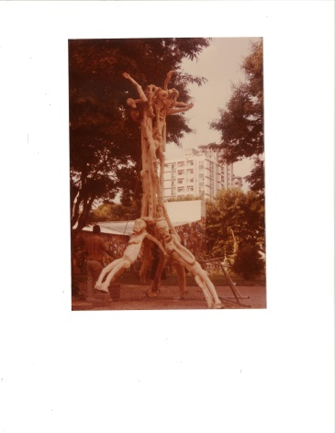  
Chissano sculpture in front of Malangatana mural, patio of the Museum of Natural History, Maputo, Mozambique, awaiting arrival of boulders, 1979. Photograph by Harriet McGuire.

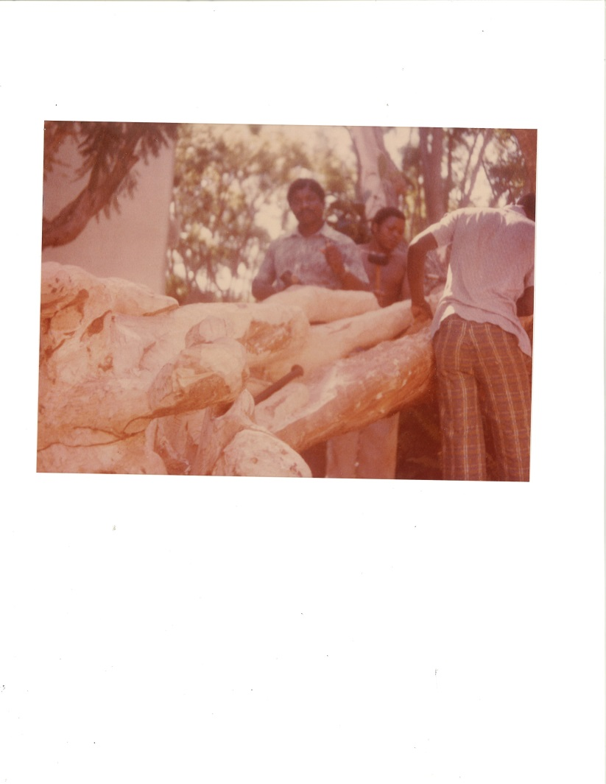

Chissano and two assistants working at the Museum of Natural History, Maputo, Mozambique , 1979. Photograph by Harriet McGuire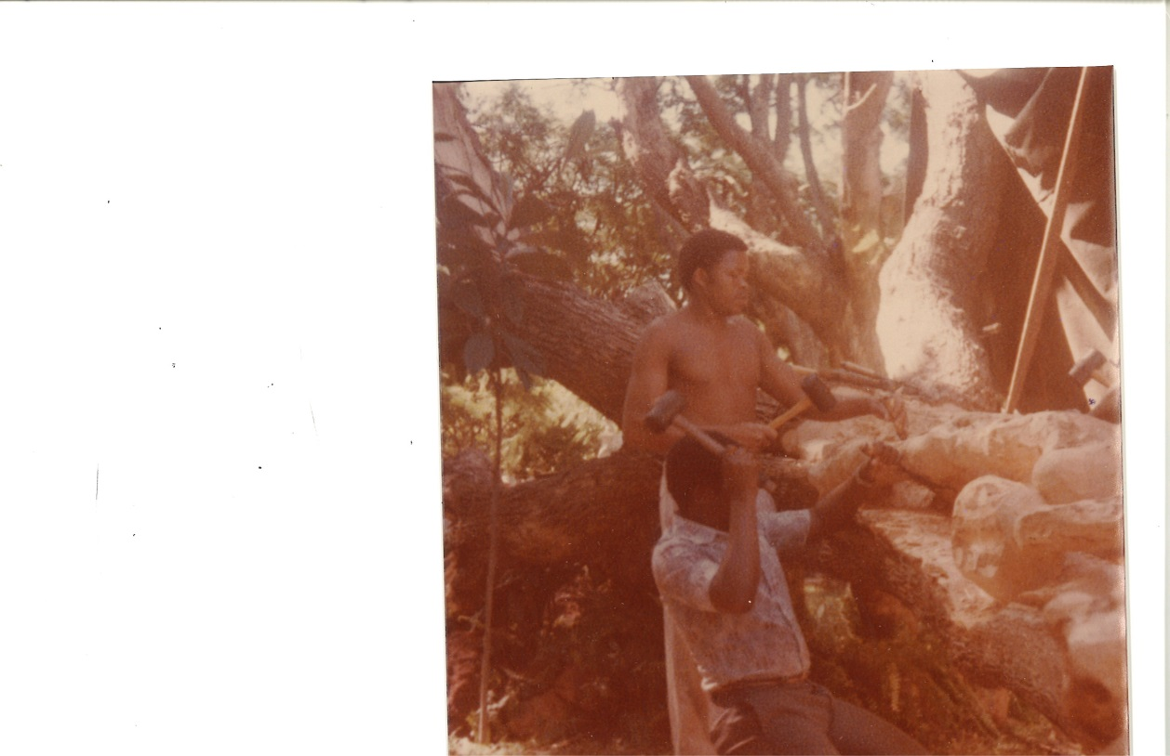

Chissano at work, 1979, photograph by Harriet McGuire